Note: In development - Links to other documents removed – Formatting needs review.

Wireless Adapters
See the Wireless Networking Datasheet for general information.
Within MeterGrapher wired and wireless adapters can be mixed in any combination. See Wired Adapters for their details – this section deals with Wireless adapters. Here you will find:
- What is delivered when you order a Wireless system
- Choice of PC
- Installing the meters
- How to connect the Adapter
- Adapter Set-up
- Trouble-shooting
- IP Addresses

The CDI Wireless Meter System
The user has specified the quantities, sizes and identifying numbers of the meters required. The system can be easily expanded at any time – See Adding New Meters below.
The system comprises:
A Digi ConnectPort X2 Adapter. This comes pre-configured with the information the adapter requires to communicate with the meters.
CDI meters according to the user’s specification fitted with wireless modules that link to the X2
A Wireless Network Data Form showing key details of the System.

Choice of PC
MeterGrapher (MG) requires a modern PC, laptop or notebook with an Ethernet connection to a router that can be connected to the Adapter.

Installing the meters
Install the meters in accordance with the WN Instructions

Connecting the Adapter
The Adapter is connected via Ethernet to a hub or router that is connected to the PC running MeterGrapher. (Do not connect the Adapter directly to the PC.)

Adapter Set-up
Digi supply a Device Discovery Utility that will find the Adapter – it can be downloaded using this link:
http://ftp1.digi.com/support/utilities/40002256_H.exe
Download the software to a file location of your choice, run it to find the adapter, and select Open Web Interface.

Set the IP address.
The use of a static IP address is strongly recommended. (See IP Addresses at the bottom of this page)
DO NOT USE the BOOTP or Auto-IP protocols
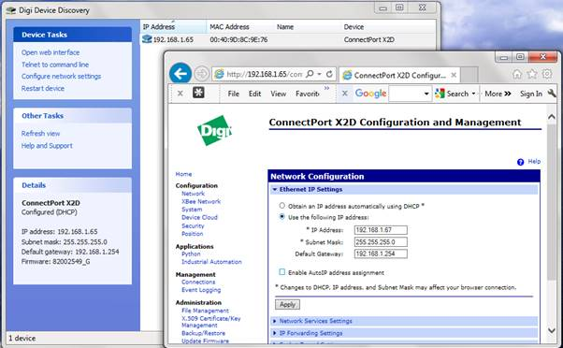
When you Run MG config type in the IP address(es) of the adapter(s) and hit Test Connections. You should see a message as shown in the picture.
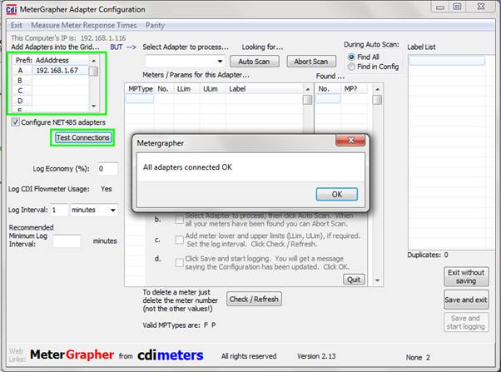
From here on you use the normal MG Configuration and Logging functions – see User Docs [Link to MG_UserDocs.html]

Trouble-shooting
Work in Progress.

Adding meters to the system
See Adding a New Meter to a Network in the WN Instructions. This is generally straightforward, but updating the ConnectPort X2 IA (Industrial Automation) table requires care. A how-to video is available showing how to do this.

IP Addresses
This section includes only the information necessary to set an address in a TCP/IP Adapter connected to MG in a simple system. If you have an extensive network and an IT guru, call them now!
IP Addresses are used in communications between devices. The PC running MG has an IP address – this can be seen in the top left of MG’s Config Form (This computer’s IP is: … ) The IP address assigned to the Adapter should be on the same sub-net. If it’s a simple system: if the PC IP is 192.168.1.116 the adapter may be 192.168.1.55, but see Existing IPs below.
If you wish to connect over different networks, see Connections over Different Networks, below.

DHCP
Dynamic Host Configuration Protocol (DHCP) is a client/server protocol that automatically provides an Internet Protocol (IP) host with its IP address and other related configuration information such as the subnet mask and default gateway.
DHCP provides an IP address on a lease for a specified duration, and when the lease expires a new one is granted. Depending on the configuration of the DHCP server a different IP address may be allocated. MeterGrapher must know the IP address of the adapter(s) connected and the user provides this on the MG Config. Form. If DHCP allocates a different IP to an adapter MG will lose connection until the user changes the MG Config. It is therefore recommended that adapters are given static IP addresses.

Existing IPs
If your PC is 192.168.1.116 you may choose 192.168.1.55. However, you must ensure that this does not already exist on your system. To do this, on the computer that will host MG:
(XP): From the Start Menu, select Run…
In the dialog, type cmd [then click OK]
(Windows 7 / 8): All programs / Accessories / Command Prompt
(Windows 10): Start Menu / All Apps / Windows System / Command Prompt
The black command prompt window appears.
Type ping 192.168.1.55 [Enter]
If you get messages saying
Reply from …
this Address is already on your system, and you must choose another.
If you get messages saying
Request timed out
this Address is not on your system, and you can use it for the Adapter.
These examples are shown below:
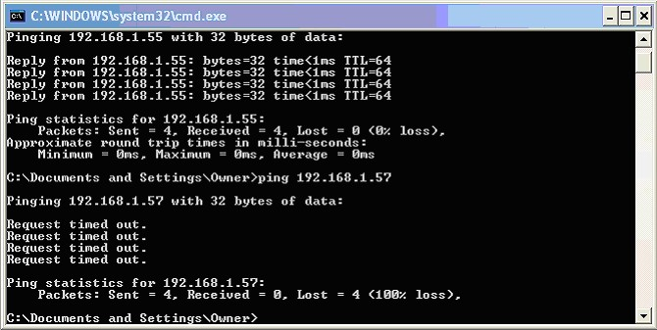
This shows that 192.168.1.55 is already on the system, and MUST NOT be used for the new Adapter.
192.168.1.57 is not on the system, and can be used.

Connections over Different Networks
If the Adapter to be connected is not on the same network as the MG PC, proceed as follows:
Wire the Adapter and meters, and configure the Adapter using a PC running the Adapter supplier’s software. Parameters can be found at the bottom of this page, under Other Adapters.
ENSURE THAT PORT 502 (THE DEFAULT MODBUS PORT) IS OPEN BETWEEN THE ADAPTER AND THE METERGRAPHER PC.
ON THE ADAPTER NETWORK, DIRECT TRAFFIC ON PORT 502 TO THE ADAPTER.
From the MG PC:
Run MG / Config, enter the Adapter network IP address, and ‘Test Connections’. When successful set the rest of the configuration.
Note that this mechanism can be used to access an established MG / Adapter / Meters set-up across the Internet. On the Adapter’s network, open Port 502 and direct Port 502 traffic to the Adapter.

