Note: In development - Links to other documents removed – Formatting needs review.

Wired Adapters (See also Wireless Adapters)
These adapters convert the RS485/Modbus codes used by CDI meters to either Modbus USB for use on COM ports or to Modbus TCP/IP for use over Ethernet. Here you will find:
- How to wire the meters together
- Choice of PC
- How to choose between TCP/IP and COM/USB
- How to connect the Adapter
- Adapter Set-up
- Details of Adapters recommended by CDI
- Trouble-shooting

Wiring the meters together
To wire the meters together, see cdi_serial_communication_datasheet.pdf. See also COM / USB With Long Cable Runs, below

Choice of PC
MeterGrapher (MG) requires a modern PC with a spare USB port and/or Ethernet connection to a router. If using COM (see below), the PC must be less than 4000 feet from the furthest meter.

TCP/IP or COM/USB?
MG will accept inputs from TCP or COM, (or both). The choice depends on various factors.
Two factors will force a choice:
If the PC is more than 4000 feet from the furthest meter, COM cannot be used
If the PC is not connected to inter/intranet, TCP cannot be used.
If the user is left with a choice, the merits of each are shown in the following table:
Factor | TCP/IP |  | COM/USB
 | Advantages | Disadvantages | Advantages | Disadvantages
Connectivity |  | Adapter must be connected to a router connected to the PC. Cannot connect directly to the PC | Direct connection to PC
Set-up | MG will set up the (CDI recommended) Adapter after it has been allocated an IP Address, but … | … User must allocate an IP Address to the adapter(s), using the software supplied with the Adapter. This requires knowledge of IP addressing rules and devices already on the system. (See IP Addresses below) | PC will allocate a COM port automatically
Set-up |  | Adapter requires a power source. | Power supplied from the PC
Cabling | Adapter(s) can be located local to meters, with data then transmitted over the inter/intranet |  |  | Dedicated cabling from meters to Adapter(s) to PC. See also COM / USB With Long Cable Runs, below
Monitoring | Meters can be monitored from anywhere on the Internet. |  |  | Meters can only be monitored on the connected PC.
Cost | Adapter costs are similar. Cabling costs may be an issue.

Connecting Adapters
Wiring details for connecting the Adapter to the meters are provided in the Manufacturer’s documentation. Further guidance for Adapters recommended by CDI is provided below. COM/USB Adapters are simply plugged into one of the PC’s USB slots. TCP/IP Adapters are plugged into a hub/router connected to the PC. Note that the Adapter cannot be connected directly to the PC.

COM/USB With Long Cable Runs
Over long distances (greater than 30 metres) the RS485 signals can suffer considerable degradation if the cabling is not of the right quality and the installation does not conform to best practice. Guidelines can be found here – https://www.maximintegrated.com/app-notes/index.mvp/id/763.
Note particularly the need for termination resistors. The resistor value should match the cable, but in practice resistors of 120 ohms will probably be fine. The termination resistors are connected across the positive and negative terminals of:
a) Each adapter
b) The furthest meter in the chain to that adapter.
If MG will not auto-detect some or all meters over long cable runs, even though a bench test using short cables is successful, the very next step is to add the termination resistors.

COM/USB Adapter Set-up
If you are setting up a COM adapter you may have to add the following information via the software supplied with the Adapter:
Baud Rate: | 9600
Data Bits: | 8
Parity Bits: | 0
Stop Bits: | 2

TCP/IP Adapter Set-up – IP Addresses
This section includes only the information necessary to set an address in a TCP/IP Adapter connected to MG in a simple system. If you have an extensive network and an IT guru, call them now!
IP Addresses are used in communications between devices. The PC running MG has an IP address – this can be seen in the top left of MG’s Config Form (This computer’s IP is: … ) The IP address assigned to the Adapter should be on the same sub-net. If it’s a simple system: if the PC IP is 192.168.1.116 the adapter may be 192.168.1.55, but see Existing IPs below.
If you wish to connect over different networks, see Connections over Different Networks, below.
DHCP
Dynamic Host Configuration Protocol (DHCP) is a client/server protocol that automatically provides an Internet Protocol (IP) host with its IP address and other related configuration information such as the subnet mask and default gateway.
DHCP provides an IP address on a lease for a specified duration, and when the lease expires a new one is granted. Depending on the configuration of the DHCP server a different IP address may be allocated. MeterGrapher must know the IP address of the adapter(s) connected and the user provides this on the MG Config. Form. If DHCP allocates a different IP to an adapter MG will lose connection until the user changes the MG Config. It is therefore recommended that adapters are given static IP addresses.
Existing IPs
If your PC is 192.168.1.116 you may choose 192.168.1.55. However, you must ensure that this does not already exist on your system. To do this, on the computer that will host MG:
(XP): From the Start Menu, select Run…
In the dialog, type cmd [then click OK]
(Windows 7 / 8): All programs / Accessories / Command Prompt
(Windows 10): Start Menu / All Apps / Windows System / Command Prompt
The black command prompt window appears.
Type ping 192.168.1.55 [Enter]
If you get messages saying
Reply from …
this Address is already on your system, and you must choose another.
If you get messages saying
Request timed out
this Address is not on your system, and you can use it for the Adapter.
These examples are shown below:
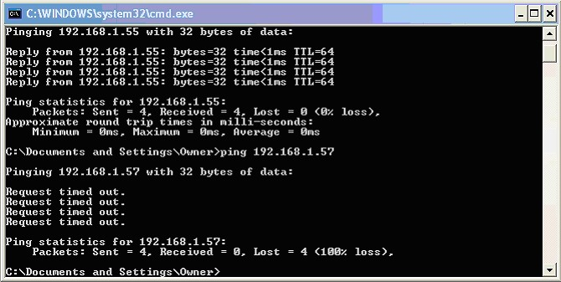
This shows that 192.168.1.55 is already on the system, and MUST NOT be used for the new Adapter.
192.168.1.57 is not on the system, and can be used.
Connections over Different Networks
If the Adapter to be connected is not on the same network as the MG PC, proceed as follows:
Wire the Adapter and meters, and configure the Adapter using a PC running the Adapter supplier’s software. Parameters can be found at the bottom of this page, under Other Adapters.
ENSURE THAT PORT 502 (THE DEFAULT MODBUS PORT) IS OPEN BETWEEN THE ADAPTER AND THE METERGRAPHER PC.
ON THE ADAPTER NETWORK, DIRECT TRAFFIC ON PORT 502 TO THE ADAPTER.
From the MG PC:
Run MG / Config, enter the Adapter network IP address, and ‘Test Connections’. When successful set the rest of the configuration.
Note that this mechanism can be used to access an established MG / Adapter / Meters set-up across the Internet. On the Adapter’s network, open Port 502 and direct Port 502 traffic to the Adapter.

TCP/IP Adapter Set-up – Configuring the Adapter
Run the software supplied with the Adapter, and set the IP Address.
NOTE: Use a valid IP Address (See above) or use DHCP to obtain an IP address automatically.
DO NOT USE the BOOTP or Auto-IP protocols
If you are using a CDI recommended Adapter this is all you need to do. MG will set up the other parameters. Make a note of the IP Address – MG will need it.
If you are not using a CDI-recommended Adapter you will need to supply additional information. See Other Adapters (below).

Recommended Adapters
CDI Meters has successfully used the following adapters: –
B&B Electronics USOPTL4 for use with USB / COM.
Wire this in accordance with the manufacturer’s instructions. Install the supplied software and run it to configure the device. It will be assigned a COM port – note this because MG will require it. If you forget the COM port:
XP: Control Panel\System\Device Manager:
Win 7 / 8: Control Panel\Hardware and Sound\Devices and Printers\Device Manager:
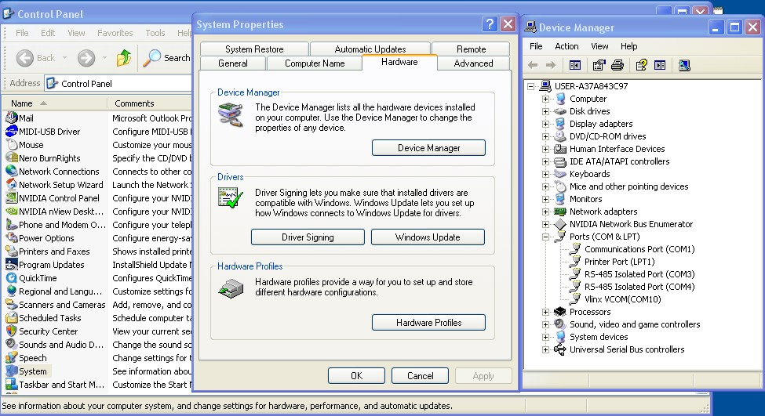
This above image shows RS485 devices on COM3 and COM4

GridConnect NET485-MB (Modbus/TCP) For use with Ethernet
Connect the recommended power supply to the adapter  Connect an Ethernet cable from the adapter to the hub / router / switch connected to the PC on which you will be running MG. Check that you have two green lights (picture, right)  Load the software supplied with the adapter on the PC, and use that software to assign the device a local IP Address. This may be static or dynamic.Note the (static) IP address or the DHCP name because MG will require it.NOTE: The adapter MUST be connected to a switch / router / hub connected to the PC, and not directly to the PC.NOTE: Use a valid IP Address (See above) or use DHCP to obtain an IP address automatically. DO NOT USE the BOOTP or Auto-IP protocols(The NET485 DHCP naming convention is in https://gridconnect.com/media/documentation/grid_connect/NET485_UM_800240_c.pdf  Paragraph 3.13.5 DHCP Naming)Note that no other configuration is required on this device. MG will set all required parameters. | 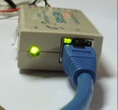
If manual configuration of the NET485 is necessary, connect via the manufacturer’s supplied software, use TelNet, and set up as follows:
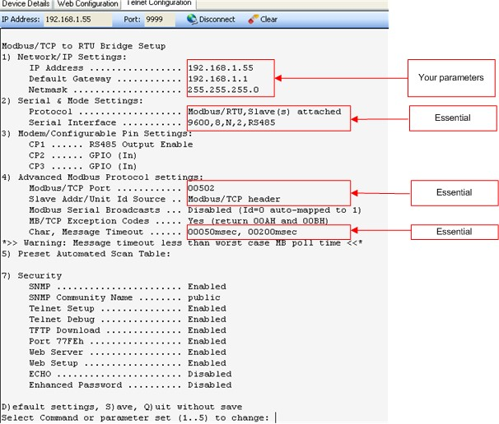
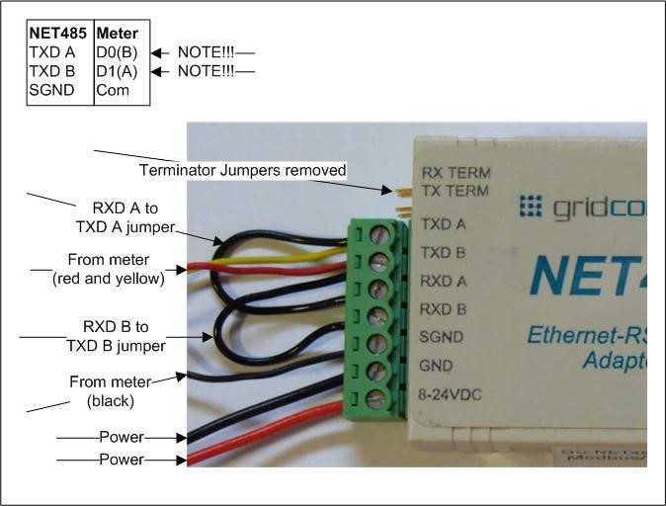 | Wire A/B from the meter to B/A on the device. Jump TXDA/RXDA and TXDB/RXDB. Remove the Terminator Jumpers. (see picture, left)
When you Run MG config type in the IP address(es) of the adapter(s) and hit Test Connections. You should see a message as shown in the picture.
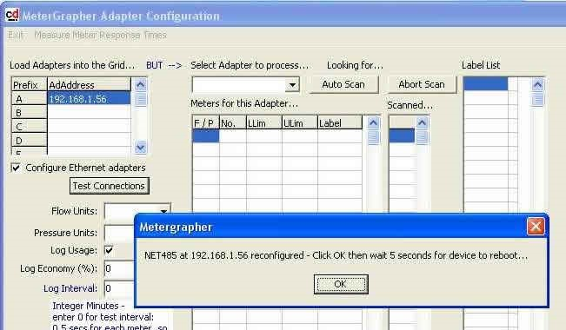

Other Adapters
Any device that has characteristics similar to either of the adapters cited above should work. However, you will have to configure the adapter yourself, and you must uncheck the Configure Ethernet adapters box on the MG config form (shown above).
Required TCP/IP Adapter parameters could include:
Baud Rate: | 9600
Data Bits: | 8
Parity Bits: | 0
Stop Bits: | 2

Attached device = slave
Serial protocol = Modbus/RTU
slave address = auto
Allow Modbus broadcasts = no
use MB/TCP 00BH/00AH exception responses = yes
Disable Modbus/TCP pipeline = no
Character Timeout = auto
Message Timeout = 0
Serial TX delay after RX = 0
Swap 4x/0H to get 3x/1x = no

Trouble-shooting
If MG cannot connect to a TCP/IP Adapter run the Manufacturer’s software to configure the Adapter. This software will indicate whether the Adapter can be reached.

If not: If the PC has been disconnected from the router and re-plugged, power-cycle the router. If this does not solve the issue review the Adapter’s IP Address (see TCP/IP Adapter Set-up – IP Addresses, above), and change as required. NOTE: Use a valid IP Address or use DHCP to obtain an IP address automatically. DO NOT USE the BOOTP or Auto-IP protocols.

If MG cannot Auto-detect some or all meters, consider the following:

While Auto-detect is running, observe the pattern of flashing lights on the adapter.
If it’s a NET485 adapter, there should be two solid green lights and one flashing green light.
If it’s a USOPTL4 adapter, one light should flash continually, while the other light only flashes when a meter is detected.
If these patterns are not observed, particularly if the USOPTL4 has lots of flashing on both lights, check all wiring. Other adapters should behave similarly.

Check ALL the Adapter parameters using the Manufacturer’s software against values given above. Even the time-out values are important!

If it is a COM / USB arrangement with cable runs over, say, 30 meters, see COM/USB With Long Cable Runs, above.

