MeterGrapher Usage Calcs
Hover your mouse over the highlighted areas for more details.
Use the “Hot Spots” below to reveal more information.
Data Selection
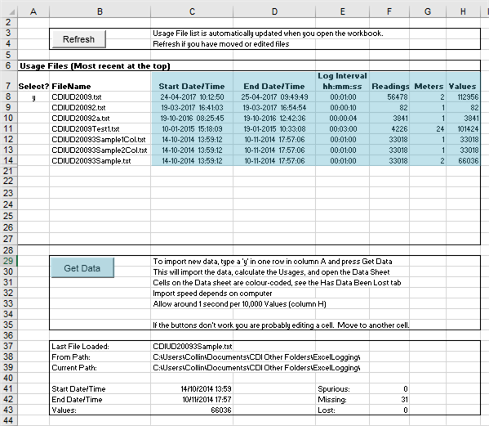
Select one file.
Really useful file information about your files.
Press this when you have selected one file.
Aggregates Selection
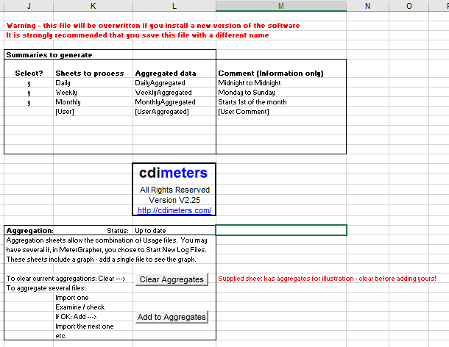
NB!
There are built-in aggregates, or you can invent your own.
NB!
Data
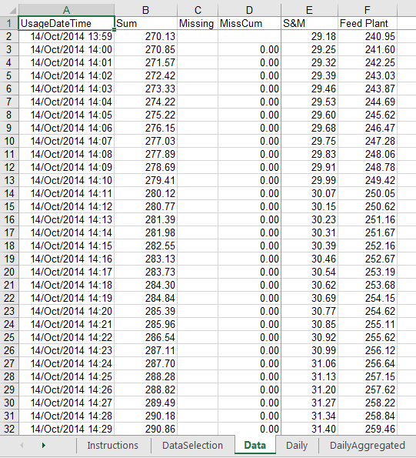
Sum across all meters.
If data is thought to be missing the value in the interval and the cumulative values are shown.
Daily
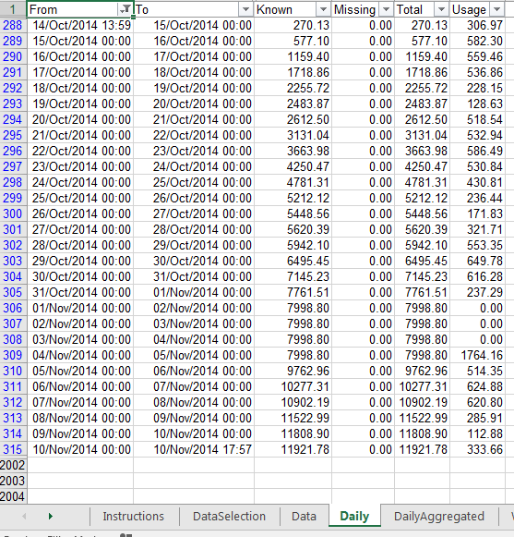
Note the part-periods at the beginning and end of the data.
Note the part-periods at the beginning and end of the data.
The Daily tab shows data for the last file imported.
Daily Aggregated
