AnswerGrapher
Users sometimes want to import logging data into Excel. A utility to aid import has been added: AnswerGrapher.
When this is initiated (user must enable macros) it shows details of the MG data files (logging period, number of meters, number of readings, logging interval). The user then selects a file to import, and as well as drawing a graph the software highlights data values that are blank or extreme (More than 3 standard deviations from the mean). Counts and percentages of these values for the last file imported are shown on the DataSelection tab. This is very useful to give a quick visual impression of the data.
Another great advantage over looking at the raw log files is that the dates are translated (in the log files it is something like 40609.369158) to a more easily undertsood format (07/03/2011 08:51:35)
Data Selection
Use the “Hot Spots” below to reveal more information.
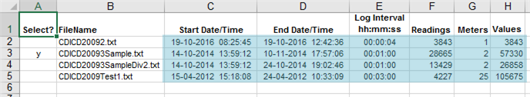
Select 1 file to import.
Information about data in the file.
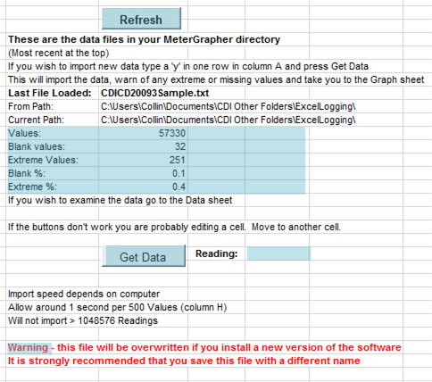
You only need this if you have moved or edited files while running AnswerGrapher.
Statistics for blank and extreme values for the last file imported.
Press this when you have selected 1 file to import.
Shows import progress.
NB!
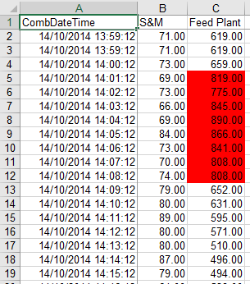
Values in red are more than 3 Standard Deviations from the Mean.
